Assignment 4 Solution

This sample solution shows a typical structure of the test plan, and how test cases are described.

Note that the tests are grouped according to the goals of the checks; in this case – according to functionality. GUI problems related to specific scenario are reported in parallel with the actual functional results. In addition, various GUI problems are summarized at the end of the document, accompanied by appropriate pictures (this is a good practice for reporting GUI problems).

The test plan is not complete: e.g. such types functionality as Undo, Deletion of states and transitions, Non-determinism indication are not addressed. Also, even though for the purpose of this exercise it is enough that every type of functionality is checked separately, a comprehensive check of the system would require non-trivial workflows. For example, create states and transitions, then move some states, delete a transition, add labels to existing transition, add more states, etc.

Creation of state-transition diagrams

# | Scenario | Expected result | Actual Result | GUI Problems
 | Start “Auto” Program;  File menu → New | A dialog box will be opened, to enter:  - alphabet of the automaton;  - the start state number. | Dialog with the required fields appears. | 1. Field "Alphabet" should be in focus (it always should be filled), to save mouse clicks.  _{2.} The buttons OK and Cancel are of different sizes.  3. The height of the text fields in the dialog is different.  4. Dialog's banner is "New Machine" instead of "New Automaton"
 | Alphabet definition:
 | Define alphabet: a, b | Empty drawing pad is opened. | As expected
 | Define alphabet: 1, 4 | No specific limitations on symbols in alphabet are defined. So either accept it, or provide a meaningful message. | The alphabet is accepted; empty drawing pad is opened.
 | Define alphabet: a, b,  (comma at the end) | Rejected, with appropriate error message | Accepted; empty drawing pad is opened.
 | Define alphabet: a, %  (non-letter and non-digit symbol) | No specific limitations on symbols in alphabet are defined. So either accept it, or reject with a meaningful message. | Rejected | Unclear message:  "Illegal Letters Format"
 | Define alphabet: a, b, …, z | No specific limitations on size of alphabet is defined. So either accept it, or provide a meaningful message. | Can enter letters till 'y' only. Upon OK, got: "Out of Memory"
 | Define alphabet: a; b  (non-comma separator) | Rejected, with appropriate error message | Rejected | Unclear message:  "Illegal Letters Format"
 | Empty alphabet: press OK without filling the field "Alphabet" | Rejected, with appropriate error message | Empty drawing pad is opened; no error message
 | Define alphabet: a, b, a  (letter duplication) | Rejected, with appropriate error message | The empty pad appears;  no error message
 | Creation of states:
 | Define alphabet:  a,b,c,d,e,f,g,h,i,j,k,l,n,m  Start state: 0  Press OK. | Empty drawing pad is opened. | The empty pad appears
 | Add state from the tool bar. | State 0 appears and is set as Start state (violet color) | As expected
 | Add state from FiniteAutomat → Add State. | State 1 appears, not colored. State addition works same as from the tool bar. | As expected
 | Repeat steps of tests 10-12, with Start state set to 1; add one more state | State 1 is violet-colored; states 0 and 2 are not colored | As expected
 | Check state amount limitation; continue to add states | No specific limit defined. So either accept all states, or provide a meaningful message when the limit is reached. | States 0-39 created normally. When trying to add one more state, the tools gets stuck and should be killed.
 | Change state properties:
 | Changing Start state:  Create 3 states; Start state is 0.  Using "State Properties" (for this, right-click on state) set state 1 as Start; and then set state 2 as Start. | State 1 becomes violet-colored; then state2 becomes violet-colored. State that is not a Start anymore (0, then 1) becomes white colored (regular state) | State 1 got violet color, but state 2 didn't (state 1 remained violet). | Dialog's banner is "Edit state" instead of "State properties"
 | Setting Final states:  Create 3 states; Start state is 0.  Using "State Properties" option, try to set state 1 as Final; and then try to set state 2 as Final. | State 1 becomes yellow-colored, and signed + ; then state 2 also becomes yellow and signed + | As expected
 | Unset property Final:  Continue test 16, by unsetting state 1 as Final; then unsetting state 2 as Final | States 1 and 2 change color from yellow to white and loose sign +. | As expected
 | Make the Start state also Final (continue test 16, and set state 0 as Final). | State 0 gets sign + and changes its color from violet to pink. | As expected.
 | For state that is both Start and Final: unset it as Final (continue test 18, unset state 0 as Final) | State 0 looses sign + and changes its color from pink to violet | As expected
 | For state that is both Start and Final: unset it as Start (continue test 18, unset state 0 as Start) | State 0 remains with sign + and changes its color from pink to yellow | State 0 didn't change its color (remained pink)
 | Creation and editing of transitions
 | Create self-loop for state:  Create states numbered 1-6.  Left click on the state 1 and then again click on the same state. Enter letter b in field "On letters" and press OK | Dialog “Add transition will appear. From and To fields will show selected states (1,1).  Arrow appears from 1 → 1 with label b on it. | Transition created as expected | 1. No arrow head.  See this picture.  2. Field “Add transition” in the dialog is not in focus.
 | Check different ways to add transitions:  1 → 2 on "a" by mouse clicks  2 → 2 on "a" from the tool bar  2 → 3 on "c" by pressing Cntr+F10  3 → 3 on "c" by pressing Cntr+F10  And the rest of the transitions by mouse clicks:  3 → 4 on c  4 → 4 on d  4 → 5 ob e  5 → 5 on e  5 → 6 on a | By mouse :  Dialog “Add transition” will appear with To/From fields filled containing the numbers of the selected source and target states.  The correct transition appears.  From tool bar or by Cntrl+F10:  Dialog “Add transition” will appear with empty fields.  The correct transition appears. | Transition created as expected | 1.Easy to confuse between double click (that opens “Edit State” dialog) and single click that starts transition arrow line.  2. Fields From/To are not empty (filled with 0's)
 | Creation of transition with multiple labels:  Click on 2 then on 4, in field "On letters" enter two or more alphabet letters | Transition labeled by the listed letters will be created | No transition created | Unclear message:  "Illegal Letters"
 | Editing transition label:  Right click on transition:  “5 → 6 on "a"; select "Transition properties", and in the dialog change the letter to f , press OK. | The arrow’s letter is changed from a to f. | No changes occurred.  The OK button does not function.  The work-around is to use Apply button instead – then the change takes place. | 1. Dialog:  See Transition properties Problems description.  2. Difficult to edit transition: need to click exactly on the label.
 | Adding labels to the existing transition:  Right click on transition:  “5 → 6 on "a"; select "Transition properties", and in the dialog change "a" to "a,b". Press OK | Label "b" added to label "a" | No changes occurred.  The OK button does not function.  The work-around is to use Apply button instead – then the change takes place.
 | Moving states:
 | Move a state. Check for :  - regular, start, final states  - isolated state  - state with from/to transitions  - state with self-loop | - State moved to its new position  - Color of state and its marking remained unchanged  - Transitions from/to the state  remained properly connected | As expected
 | Save the diagram as auto_ex1.Yha | The file is saved on the disk | The file is saved on the disk
See Additional GUI problems.

Simulation of state-transition diagrams

Run the application with auto_ex1.Yha automate (Continuation of previous test)
See this diagram:

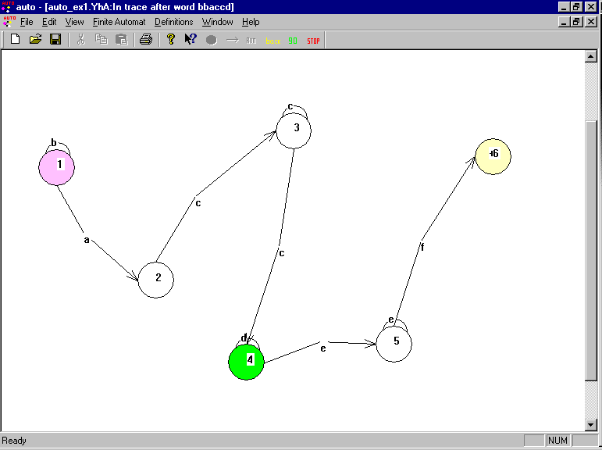

 | Run on empty word:  Press Run from tool bar. In the Run dialog do not enter any word and press OK. | Error message will appear about empty word. | As expected. | 1. Wrong banner – Trace instead of Run  See more…  2. Field "From state" is misleading and shouldn't be there at all. The run should begin from the Start state.  3. Error message is not phrased well.  See Error handling problems description.
 | Finite Automat menu → Run Automat.  Enter a word that the automaton will accept:  bbaccdeef | The automaton will run and will pop up with successful message | As expected. | Inconsistent terminology in the message.  See Error handling problems description.
 | Stepwise run:  Enter the same word, and check the box "Trace".  In the tool bar, press "Go" to perform steps. | The word will be accepted. After every step, the currently active state has green color. | As expected. | 1. There is one way to trace – only from tool bar. The standard is that there will be the same option in the menu (plus a shortcut)  2. Problem with reporting of stage progress place
 | Enter the word that the automaton will reject:  ababa | The word is rejected. | As expected.
 | Same word, stepwise run | The word is rejected. | As expected
 | Illegal word (uses letters not in the alphabet) : qwert | Error message about illegal letters | No error message. The word is rejected.
 | Run automaton that has no final states  Unset state 6 as final;  enter word bbaccdeef | Error message saying that there are no final states. | No error message; the word is rejected.

Dialog Problems

Entrance to State/Transition Properties dialogs is possible only by clicking right button. Usually there would be also an option to select the state/transition and to edit it from the menu.

The option in the pop-up menu is called “State Properties”, while the dialog banner is “Edit State”.

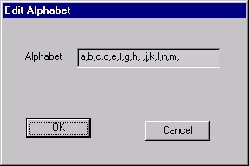
In most dialogs, buttons OK/Cancel are in different sizes, the labels and text fields are not aligned. For example in “New Automat” dialog, Edit Alphabet:

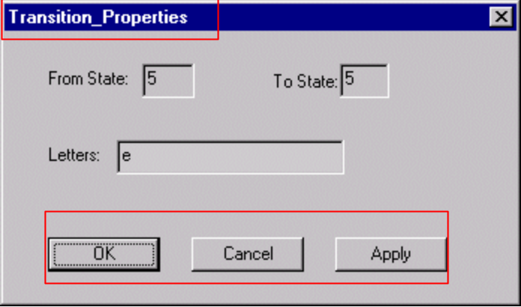Transition Properties:

- The banner is not standard (words connected by underscore)
- The text fields/labels are not aligned.
- Apply button is not consistent with the rest of dialogs in the tool (for example, dialogs “Edit Alphabet”, “Edit State” have only 2 buttons: OK and Cancel.)
- Apply button also closes the dialog – according to the standard, it should not.
- OK button does not function, only the Apply.

Creation of New Automaton:

Buttons have different size:

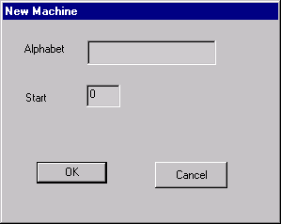
Run Dialog Box:
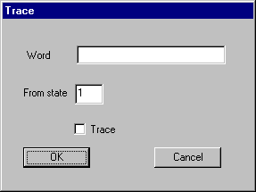

This dialog has wrong title – “Trace” instead of “Run”

Shortcuts and Accelerators:
Shortcuts for some important commands are missing - “Go”, “Back”, “Stop”.

Menus:

In menus, there are no options for tracing (stepwise run): “Go”, “Back”, “Stop” – these options exist in the tool bar only. The standard is that there should be also key shortcuts and menu options.

In Edit Menu:
Standard options are missing Copy, Paste, Cut, Redo, Select All, Delete.
Although they are in the tool bar, but the standard is: the tool bar is the shortcut to the menu options. It’s impossible to select state/transition and to delete it from the menu.

In View Menu:
Options: Zoom In/Out, Fit To Screen, Percentage viewing can be helpful. That could be very useful for this kind of application, since the states could be placed everywhere in the drawing pad.

It’s more intuitive that “Mark NonDetermenistic” option will be in the View menu.

Tool Bar:
- Also that kind of tool bar could be very helpful, like (zoomig the automaton):
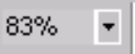

- Cut, Copy, Paste toolbar is never active.



- “Undo” does not appear in the tool bar – this is standard.

- Tool bar options do not have tool tips, but have status bar at the bottom of the window.


The Windows standard tool bars do have tool tip (Print, Copy, Paste, Save, Open, New, etc…)

Fonts and Colors
Fonts and Colors could not be customized.
The tool Bar: option Run/Back/Go/Stop colors do not combine well and are not visible well.

Refreshes
Restoring internal window causes redraw bug. (minimize and restore window).

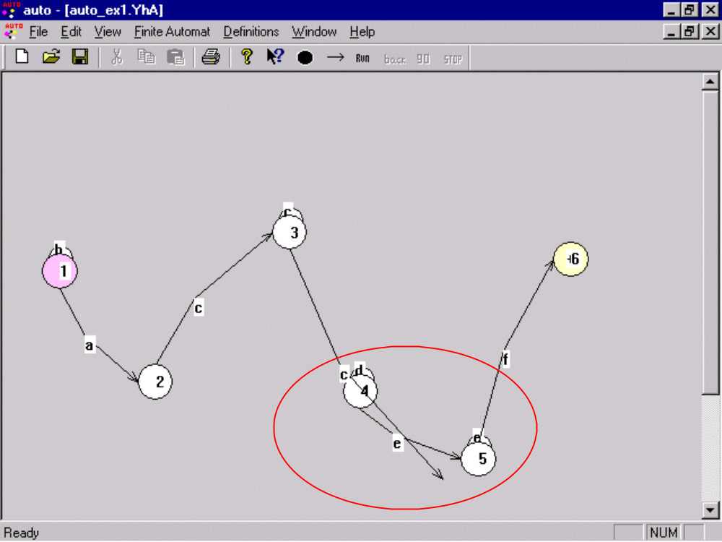

Place on Screen
  - During a stepwise run, the progress report is shown in the window banner. During the run, it is not convenient to look at the window banner. There should be special place for trace progress messages. If input word is long, there won’t be place for this at all.

Additional GUI Problems:
1. Horizontal scroll bar is missing, even if needed (see the picture). It makes hard to navigate within the screen.

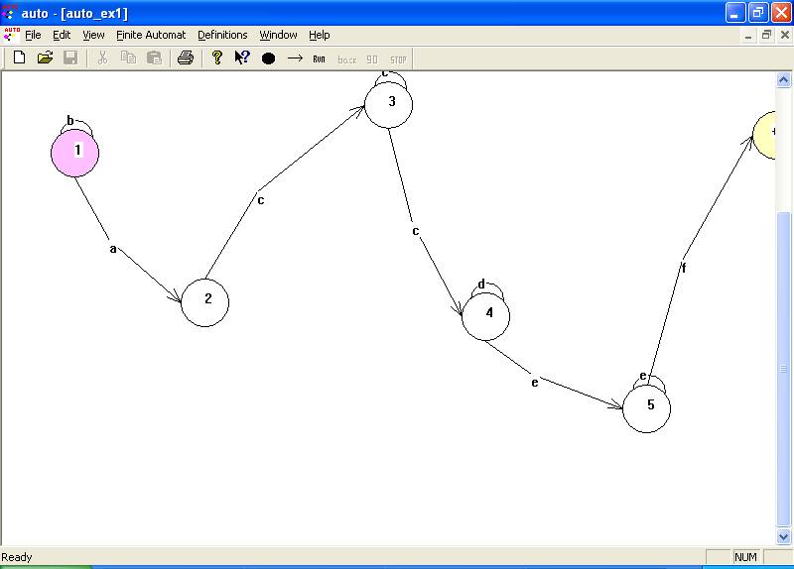

2. Self-loop problem
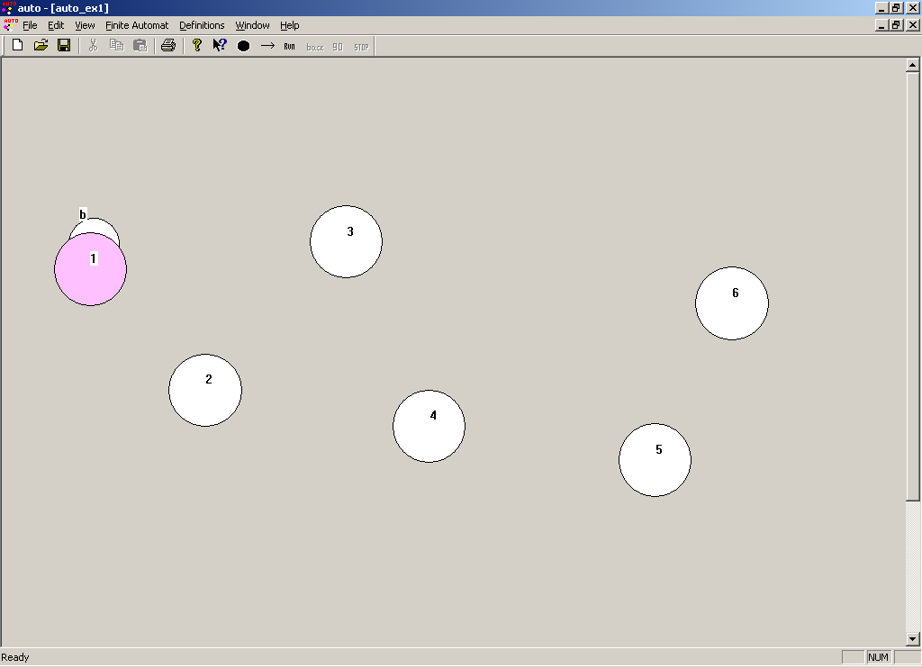

Error handling:
- When the given letter for transition does not exist in the alphabet – the error message is not helping and written incorrectly “illegal letters”.
- Some errors are not phrased well and not clear. For example: "Illegal from state" (should be “From-state is not defined” or “From-state has to be an existing state” – depending on specific case).
- Inconsistent terminology: when running automaton, the application opens dialog to enter a word when the run finishes, the message says “FA accepted/rejected the string”
- There is no warning/info message:
When trying to run Automaton with no Final state.
When there is state with no transition
- When trying to run the application and no word is entered – the message: “You must enter aword” is shown – there is spell mistake “aword”. This message is not phrased as well.

BACK to the tests

